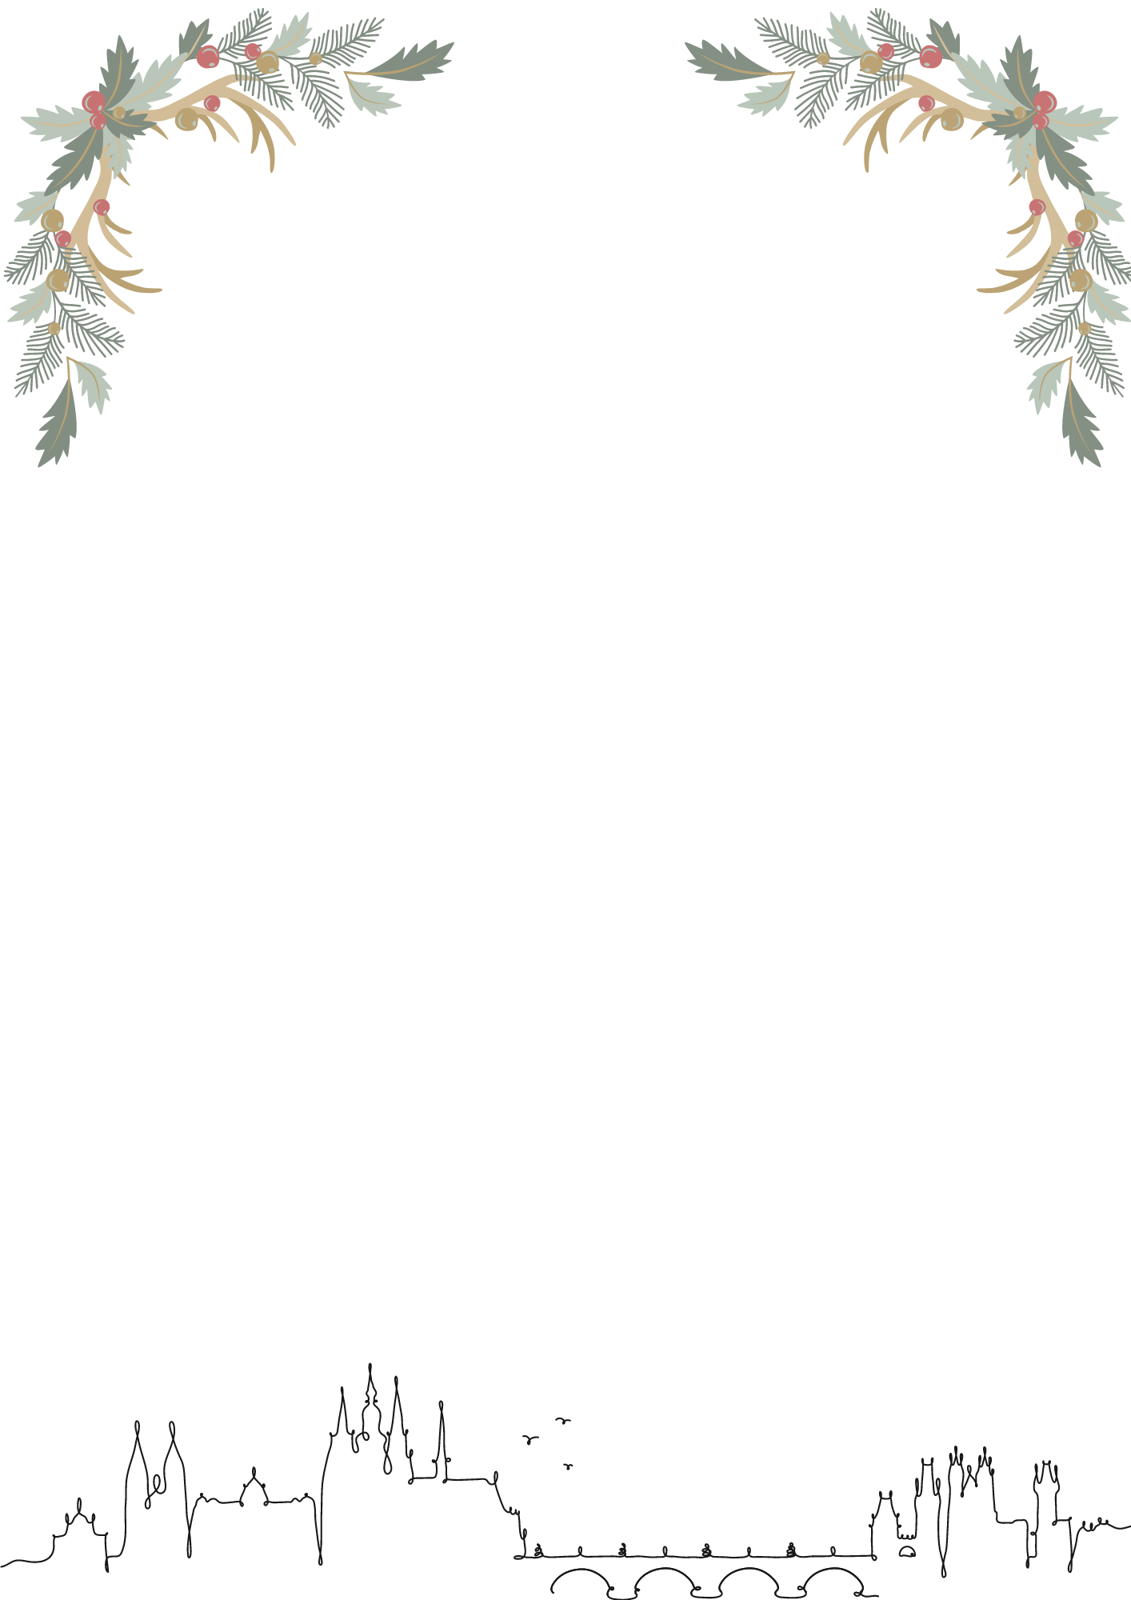

Preliminary entry form – Christmas Prize Prague 2024
Country, Club (Club abbreviation):
Contact:
- 12U
  - Free team:
- YOUTH:
  - Figures:
  - Solo F:
  - Solo M:
  - Duet:
  - Mix duet:
  - Team:
  - Free combination:

- SENIORS:
- Free routines
  - Solo F:
  - Solo M:
  - Duet:
  - Mix duet:
  - Team:
  - Acrobatic routine:
- Technical routines
  - Solo F:
  - Solo M:
  - Duet:
  - Mix duet:
  - Team:

- OTHERS:
- Coaches:
- Judges:
- Technical Controller:
- Preliminary number of lunches (Non-binding):
Date:
Signature:

